**ANALYZING THE PERFORMANCE AND EFFICIENCY OF THE RADISSON HOTELS USING DATA VISUALIZATION TECHNIQUES**

**LONGITUDE AND LATITUDE**

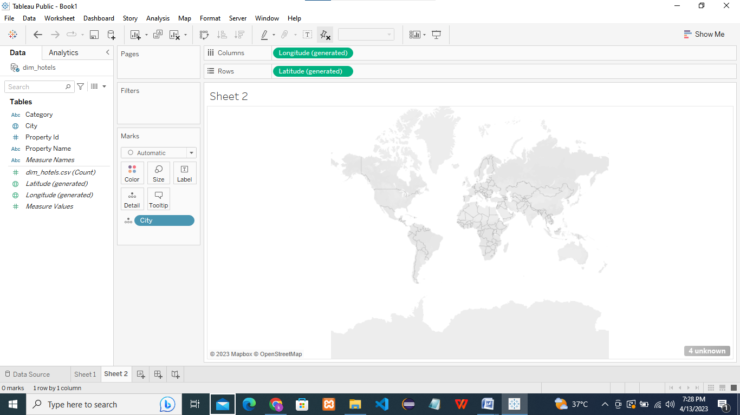

**DIM HOTEL.CSV AND CITY**

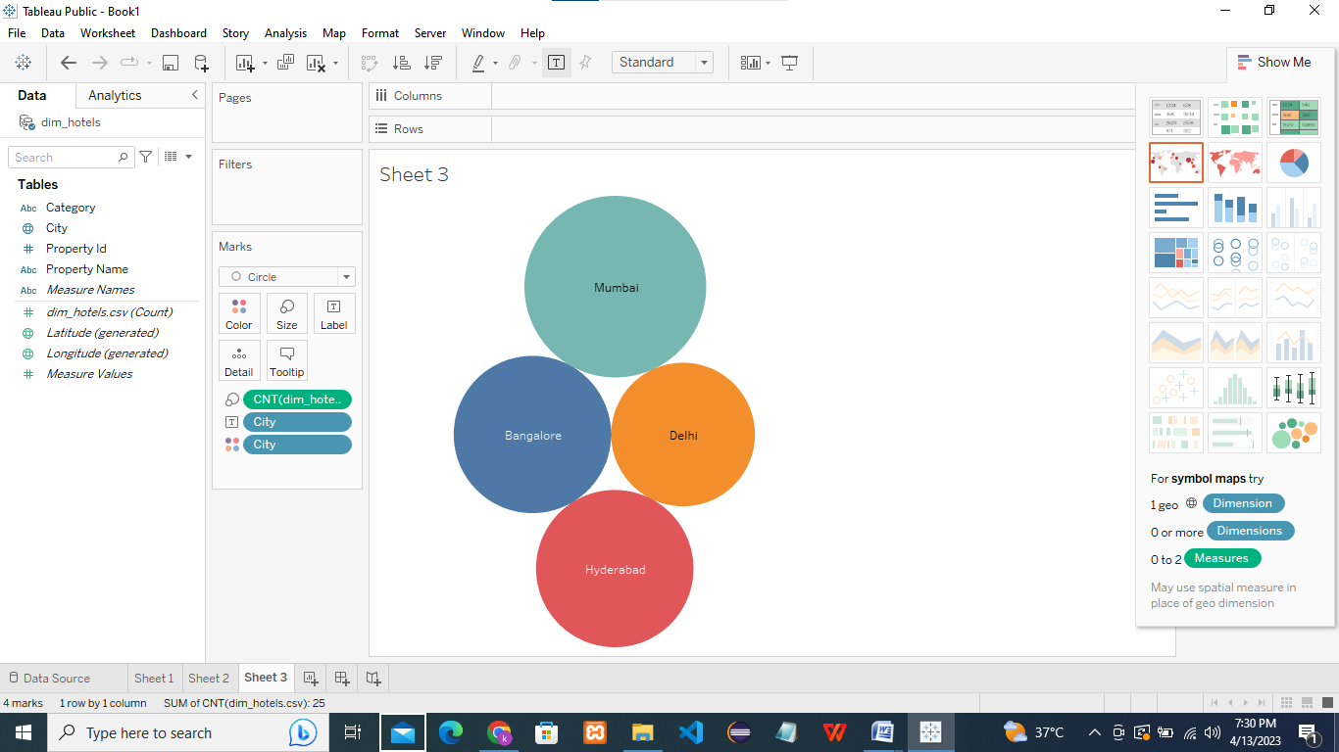

**PROPERTY ID AND PROPERTY NAME**

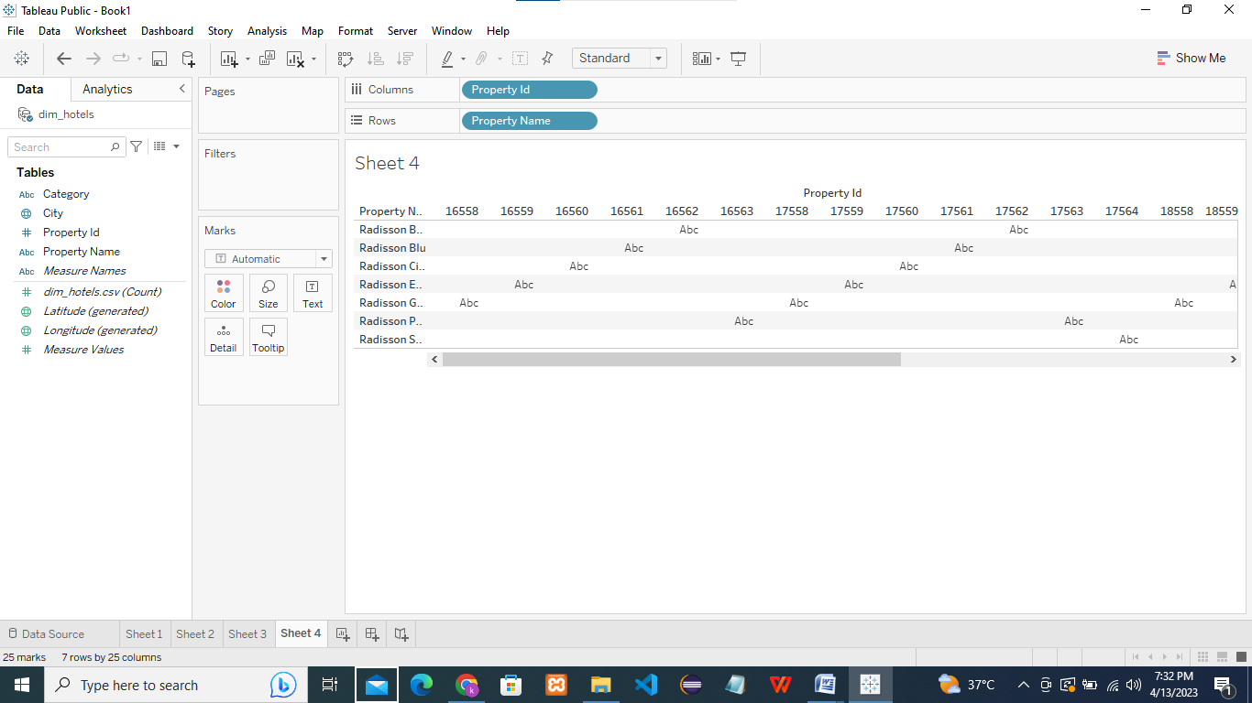

**PROPERTY NAME AND DIM HOTEL.CSV**

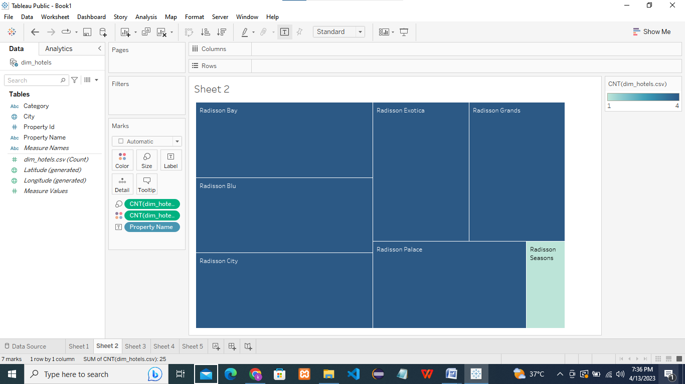

**CATEGORY AND DIM HOTEL.CSV**

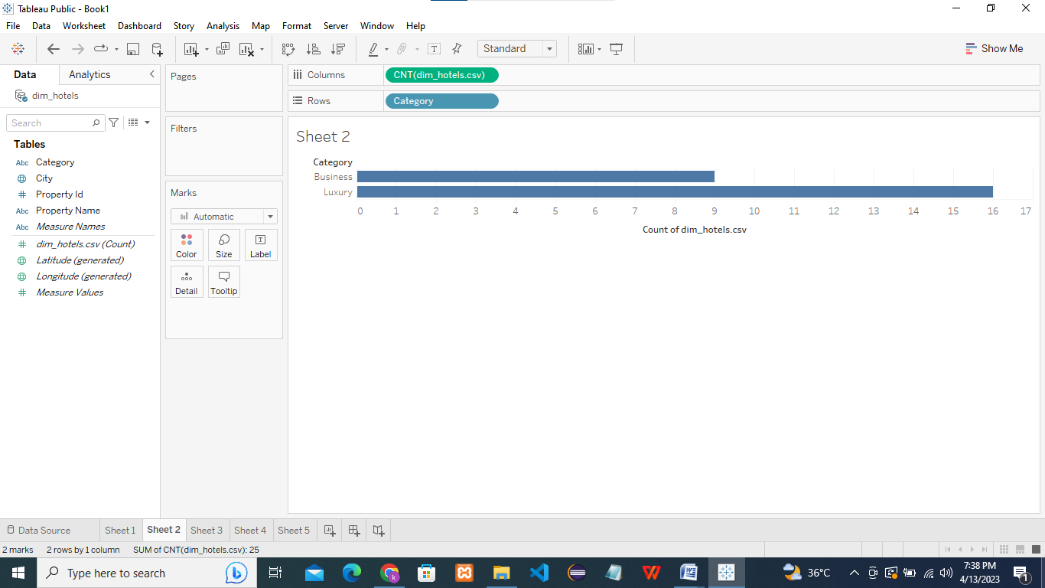

**CITY,PROPERTY ID,PROPERTY NAME AND DIM HOTEL.CSV**

